Note: The information in this article has been adapted from the original work published in Crop Science titled "Water Storage in Putting Greens Constructed with United States Golf Association and Airfield Systems Designs" (Mc/nnes and Thomas, 2011, 51:1261-1267) and in HortScience titled "Water Flow Though Sand-based Root Zones atop Geotextiles" (Rose-Harvey et al., 2012, 47:1543-1547). The research was collaboratively funded by Texas A&M University, Airfield Systems (Oklahoma City, OK), and the United States Golf Association.

Airfield Systems offers an alternative to the standard USGA putting green design. Their design utilizes a highly porous, 1-inch deep plastic grid (AirDrain, Figure 1) in place of a 4-inch deep gravel layer. As with gravel, AirDrain allows rapid lateral movement of excess water to drains and thus provides for uniform horizontal moisture content within the root zone. While voids in AirDrain are very effective in transmitting water, they are much too large for the sand in the root zone to bridge for self-support so a geotextile is used atop the grid to prevent infilling of the void space. Use of geotextiles in putting green construction has been controversial due to the perceived potential for clogging of the fabric by migrating fine particles and eventual loss of permeability.
We became interested in the hydraulic performance of the Airfield Systems design after Texas A&M University constructed a soccer field with the Airfield System design in 2002. Anecdotal evidence from field managers suggested that the new field required less frequent watering than the University's football field that had been constructed following the USGA design. While the two fields were constructed with different root zone mixtures and the physical environments surrounding the fields are quite different, we suspected that there may have been a difference in the amount of water stored in root zones on fields constructed with the two designs (i.e., a difference in the vertical distributions of water content in the root zones). We knew from the physics of water in sand that the amount
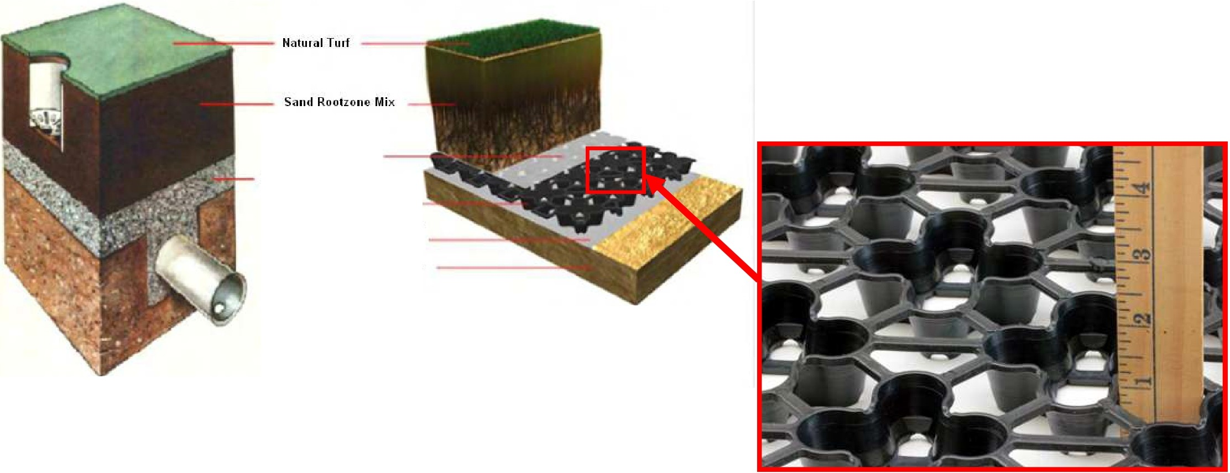
of water stored in a root zone decreases

USGA Putting Green AirField Systems Green
with increasing tension at the bottom of the root zone, and we expected because of the geometrical and physical differences in the designs that there would be differences in water tension at the bottom of the root zones.

Geotextile
4-inch Grnvel Layer
AirDrnin Geogrid
hn1)erme:ahle Line, or Geotexrile
Prep.1red Sub-Base

Figure 1. The highly porous, 1-inch deep AirDrain (right) offers an alternative to the 4-inch deep gravel layer in the standard USGA putting green design (above left).

©2013 by United States Golf Association. All rights reserved. Please see Policies for the Reuse of USGA Green Section
TEROVol.12(4):6-101 July-August 2013
TGIF Number: 224057

GRP.SSSURFACE

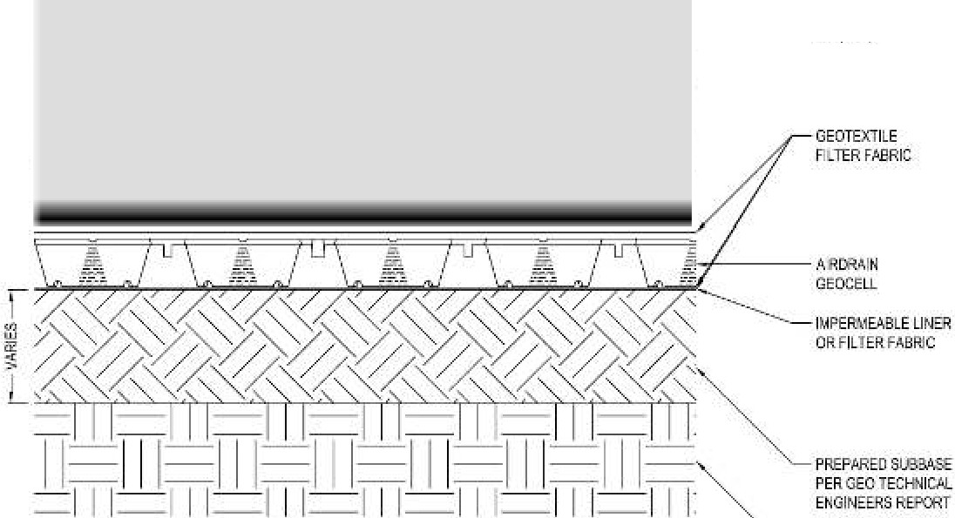
---SPECIFED
SAA'OROOT lO EM

PR.e.PAREOSU DI P&:RGEOTL:CliNICl,J. ENGINEERSREFCITT
SECTION

Cross-section of a putting green using the AirDrain instead of a 4-inch gravel layer in a USGA green (Drawing courtesy of Airfield Systems).
While the root zone may be saturated above the drainage layer, the water is under tension so the term "perched water table" often used to describe the state of water in the root zone immediately above the drainage layer is a bit of a misnomer. A better term might be "perched capillary fringe." Capillary fringe is the saturated zone above a water table where water is under tension. The further upward from the bottom of the root zone the greater the water tension. As distance increases upward and water tension increases, the root
To test for differences in tension developed at the bottom of the root zones of the two designs, we constructed laboratory-based test cells from 4-inch diameter PVC pipe containing profiles of the Airfield Systems and USGA greens. Using tensiometers, we were able to demonstrate that the tension that developed at the bottom of the root zone in the Airfield Systems design was appreciably less than that in the USGA design. At that point we thought it worthwhile to investigate this finding on a slightly larger scale and a more realistic setting. To this end, we constructed test greens in 14-inch diameter PVC pipe. Three sands and three gravels were chosen such that they covered the ranges from coarser to finer sides of the USGA recommendations for particle size distribution. To create root zone mixtures, the coarser two sands had peat moss added to increase water retention. The finer sand was

.
16
top of root zone
"w' ¹²
su::

C
this area represents the amount of water stored in the profile
(about 3 inches)
.s::
"w'
0;;; 8
C:
u
C:
.N...
₃"'
2
4
tension at bottom of profile= 2.5 inches

·

zone eventually begins to desaturate as the largest
0.00
0.10 0.20 0.30
040

pores drain. As distance increases beyond this height water content continues to decrease. As a consequence, the tension that develops at the bottom sets the starting tension and determines the thickness of the saturated zone and the amount of water stored in the root zone profile (Figure 2). The depth and hydraulic properties of the drainage layer determine the magnitude of tension that develops at the bottom of the root zone.
AirDrain is 1-inch deep so the maximum tension that
16 , ,

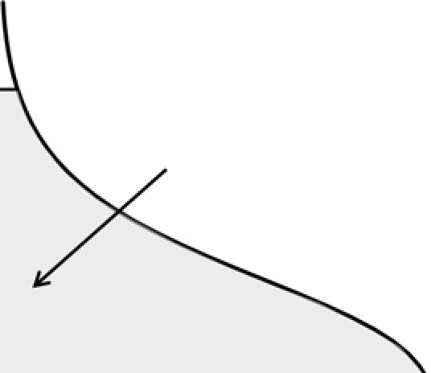
.,, 12
tooropoft zone
this area represents the amount of water stored in the profile
(about 3.5 inches)
.s::
"w'
u
.-N.=..
tension at bottom of profile= 0.5 inches
w
.s::
u
C:

C:
- 8
C:

2

can develop at the bottom of the root zone during drainage in the Airfield Systems design would be 1 inch of water. Gravel is typically 4 inches deep so the tension that could develop would be up to 4 inches of water, depending on the hydraulic properties of the gravel and the depth to which sand ingresses pores of the gravel. Water is slow to drain from small pores into
3"'
4

0
0.00 0.10 0.20 0.30 0.40
Water Content (inch of water per inch of root zone)

large pores, but if both systems were sealed from evaporation the tensions would eventually reach 1 and 4 inches at the bottom of the root zone in the Airfield Systems and USGA design greens, respectively. An occasional finger of sand penetrating the gravel in the USGA design green can lead to an appreciably quicker increase in tension at the root zone gravel interface.
Figure 2. Graphic representation of the dependence of water-holding capacity on tension at the bottom of the profile for a typical root zone mixture meeting USGA recommendation for total, air-filled, and ca­ pillary porosities. The curved lines to the right rep­ resent the relationship between water tension and water content for the root zone mixture.

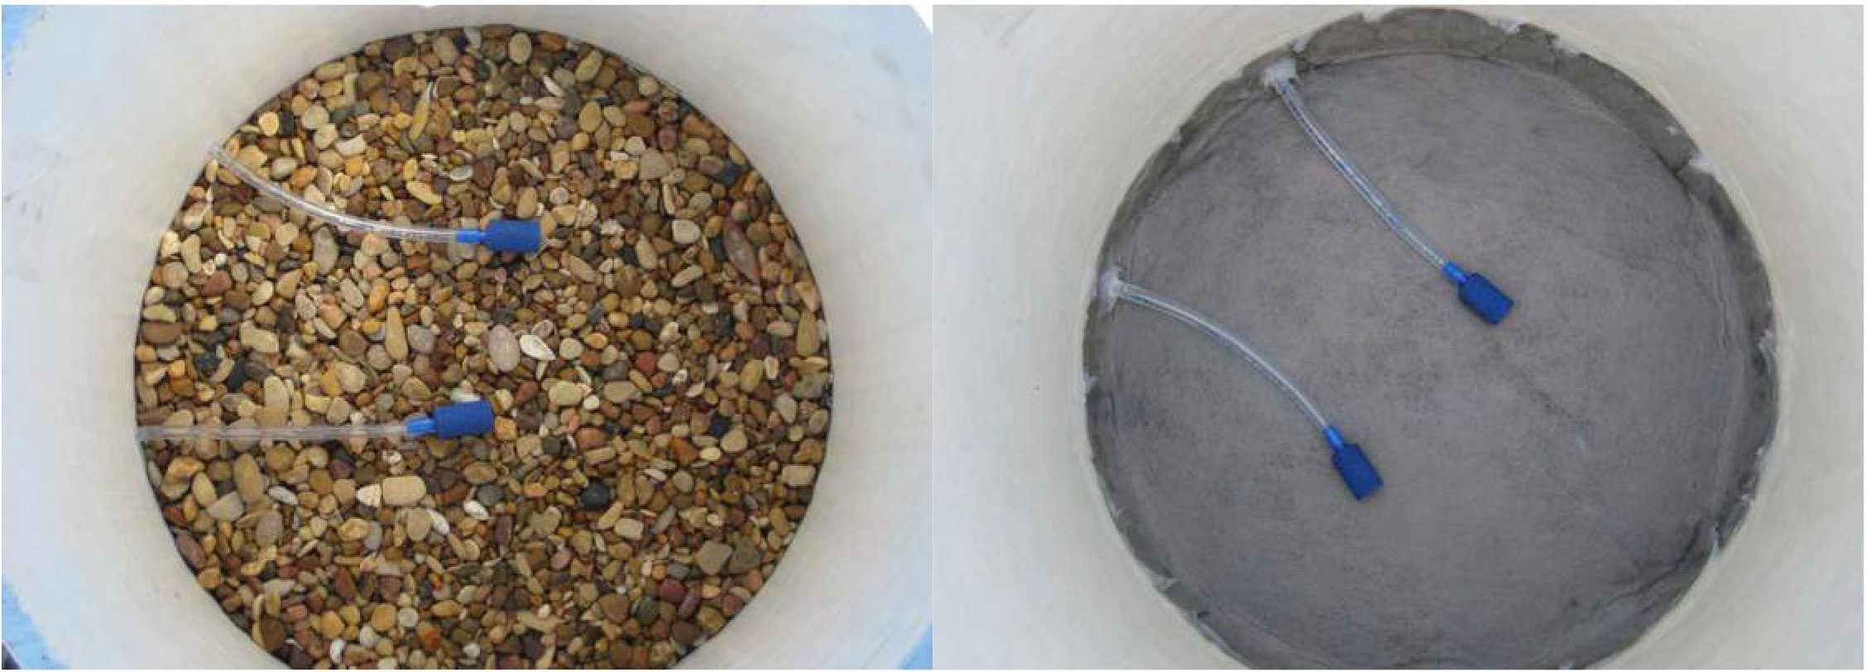

Figure 3. Test greens constructed in 14-inch PVC pipe with either gravel or geotextile atop AirDrain as the drainage layers. Both types of test greens contained a pair of porous cups connected to plastic tubing that formed manometer-tensiometers to allow measurement of water pressure or tension at the root zone­ drainage layer interface.

not amended. These three root zone mixtures were used in combination with the three gravels to construct test greens of the USGA design. The gravel layer in all of the test greens was 4 inches deep. An intermediate choke layer of coarse sand was not used. The same three root zone mixtures were used in combination with four geotextiles atop AirDrain to construct test greens of the Airfield Systems design. We used the Lutradur polyester geotextile prescribed by Airfield Systems at the time and chose three additional geotextiles that had the same apparent opening size (0.2 mm), but differed in material and/or manner of construction. Manometer­ tensiometers were used to measure pressure or tension that developed at the root zone-drainage layer interface of both designs (Figure 3). After the test green columns were packed with 12 inches of the root zone mixtures they were sprigged with MiniVerde bermudagrass supplied by King Ranch Turfgrass­ Wharton Farms (Wharton, TX). Following a period to grow-in the grass, a series of experiments were conducted that measured the amount of water stored in the root zone profiles and the water tension that developed at the bottom of the root zones of the different treatments after irrigation and drainage.
Vertically oriented time domain reflectometry TD R
probes were used to measure the amount of water stored in the root zone profiles (Figure 4).
Periodically during the course of the study, the test greens were watered until drainage was observed and then the amount of water stored in the profiles and the water tension at the bottom of the root zones were recorded for 48 hours. As with our preliminary lab study, we found that the water at the bottom of the root zones of test greens constructed with the Airfield design
was under less tension than the water in test greens constructed with the USGA design, by about 2.2 inches of water tension (Figure 5). This lower tension was associated with an increase in water storage of about
0.5 inch in the Airfield System design greens above that in the USGA design greens (Figure 5). This increase in water retention could lead to less frequent necessity to irrigate.
Because of reduced tension at the bottom of the root zone, these results also implied that the tension at which root zone mixtures should be tested for capillary porosity when intended to be used in an Airfield System design green should be reduced to achieve similar
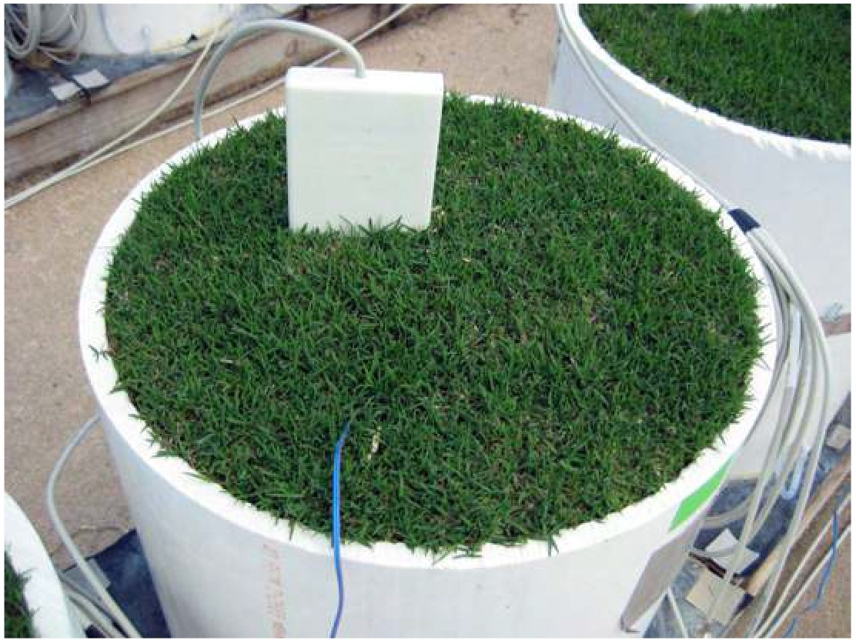
Figure 4. Test green with vertically installed, 1-ft long TDR probe used to measure average water content within the root zone profile.

3.2

vi" 3.1
<I)
..r::
u
-C 3.0
<.:: 2.9
e
n.
C
_{"C} 2.8
<I)
year-long laboratory experiment to investigate a range of geotextiles that were suited to supporting sand in the Airfield System design and determine whether or not they limit drainage out of the root zone. In this experiment, 6-inch diameter PVC columns were used to contain combinations of 12 inches of three sand mixes with 10 geotextiles held atop AirDrain (Figure 6). Manometer-tensiometers again were used to measure
pressure or tension at the sand-geotextile interfaces.
/ri\
"-1 | Airfield Systems designI
I USGAd . nr I
eslg
 | I |  |  |  | l | ./

.9
"2"
:"i:'

2.7

2.6

2.5

0.0 0.5 1.0 1.5 2.0 2.5 3.0 3.5
Water Tension at Bottom (inches of water)
Mix 1 had a particle size distribution that ran down the center of the USGA specs. Mix 2 was made by blending Mix 1 with a sandy clay loam (9:1 by mass) and Mix 3 was made by blending Mix 1 with a sand having excess fines (1:1 by mass). Mix 1 and Mix 2 met USGA recommendations. Mix 3 contained twice the recommended amount of very fine sand. The apparent

Figure 5. Range in the mean amount of water stored in 12-inch root zone profiles in Airfield Systems (geotextiles atop AirDrain) and USGA (gravels) design test greens 12 hours after irrigation. Means were of the three root zone mixture treatments and variations shown were from drainage-type treatments (i.e., type of geotextile or gravel). Stored water in the profile was measured by TDR and water tension was measured with manometer­ tensiometers.

moisture retention to greens built according to the USGA recommendations. In doing so, slightly coarser sand would meet specifications for capillary water retention in the Airfield design. Conversely, sands that push the very fine side of the current recommendations might not meet specifications for air-filled porosity.
The question of whether or not geotextiles used in a green will clog with fines migrating out of the root zone was also studied. To address this issue, we conducted a
opening sizes of the geotextiles used ranged from O.15 to 0.43 mm. After the sands were added to the columns they were regularly irrigated. Periodically, the rate that 1-inch of irrigation water drained from a column was measured and the pressure/tension at the sand­ geotextile interface was recorded.
For the first six months, any particles that washed out of the sand through the geotextiles were accumulated and analyzed for total dry weight and particle size distribution. At the end of the study, the saturated hydraulic conductivity of the sand-geotextile combinations were measured. Statistical analyses showed that drainage rate, saturated hydraulic conductivity, and mass of eluviated particles were not dependent on the properties of the geotextiles, but rather on the properties of the sands (Figure 7). Most all of the particles that washed out of the columns were of clay and silt sizes. This could be construed as evidence that the geotextiles were sieving out larger particles, but we found that the size of particles in the drainage water was not related to the apparent opening size of

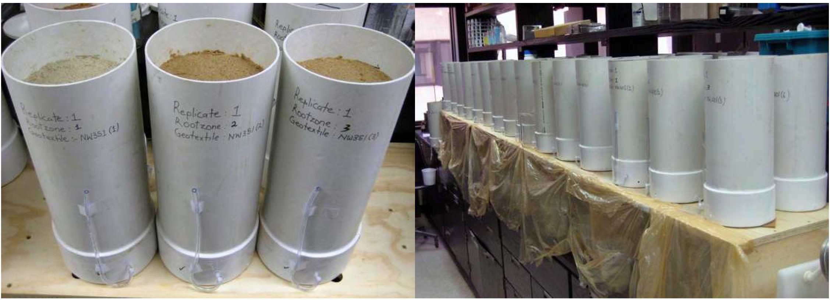

Figure 6. Columns used to measure potential clogging of geotextiles by fines migrating out of the root zone.

0.00001 0.0001 0.001 0.01
Particle Diameter (mm)

0.1
pressure atop any of the geotextiles during drainage, as would have occurred if the geotextile had been restricting drainage out of the column.
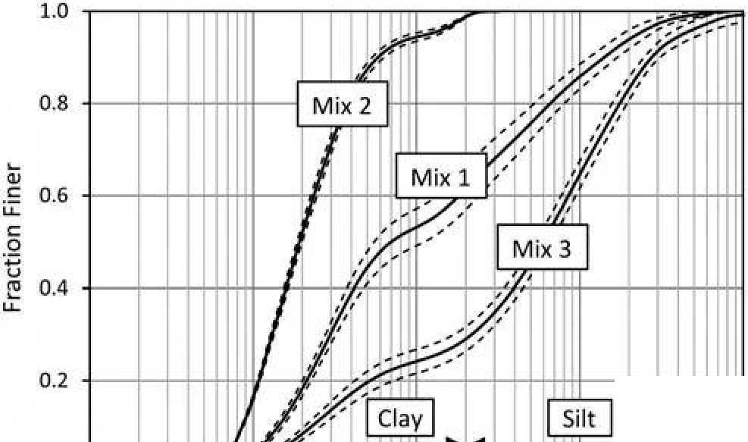
In conclusion, the results of our studies gave no reason to prevent more widespread use of Airfield Systems' design as an alternative to the USGA method for putting green construction. Airfield Systems design produces additional water holding capacity above the USGA design, which leads to more plant available water, given the same root zone mixture, and, possibly, less frequent requirement for irrigation. Our data also support the general use of properly sized geotextiles to support sand based root zones in putting greens.

[san
o.o +--"l'---'-1..J.l_..1.i,._., .._,,1 f-...- ._-1'-I ---'-'Il--'1-41--'--..1..,_1--'l....,_I-'-'Il..,_.1l1_+.-.:. J...-"T'-1'-YII
Geotextiles with apparent opening size of 0.2 mm worked well in our test greens and a woven geotextile with an apparent opening size twice as large (0.43 mm)

Figure 7. Size distribution of particles washed out of the three sand mixes through the geotextiles. The solid line for each sand mixture represent the mean fraction of particles finer than a given diameter over 30 columns containing the mixture (1 0 geotextiles with 3 replicates) and the dashed lines represent one standard deviation each side of the mean.

the geotextiles, which it should have been if the geotextiles were acting as sieves (i.e., the geotextiles with the larger AOS would have let larger particles pass, and vice versa, but this did not happen). The geotextiles obviously prevented the passage of particles as their purpose is to prevent migration of the root zone sand into the drainage layer, but it appeared in our study that the sands were responsible for determining the particle sizes leaving the columns.
Drainage rates from the columns containing the sand without added fines increased over the year, presumably because pore channels in the sand were widened when silt and clay washed out of the profile.
Drainage rates of the columns containing the two sands with additional fines decreased over the year, but the decrease was not statistically related to the properties of the geotextiles. To test if the sands themselves were clogging, saturated hydraulic conductivities were measured as layers of sand were removed from columns. Since saturated hydraulic conductivity would not depend on the depth of sand in a hydraulically uniform column, any observed changes would be due
to difference in the conductivity of the layers removed compared to those remaining. We found that when surface layers were removed the saturated hydraulic conductivity increased, indicating that the surface layers had lower conductivities. This was not too surprising as the majority of inter-particle pores of sand meeting USGA recommendation are smaller than the apparent opening sizes of the geotextiles we tested. In support of our conclusion that the sands were clogging and not the geotextiles, we did not notice a build-up of positive
retained the root zone sand just as well.
Summary Points

- Water at the bottom of the test green rootzones constructed with the Airfield design was under less tension than the water in test greens constructed with the USGA design (about 2.2 inches of water tension).
- This lower tension was associated with an increase in water storage of about 0.5 inch in the Airfield System design greens above that in the USGA design greens.
- Geotextiles with apparent opening size of 0.2 mm worked well in test greens and a woven geotextile with an apparent opening size twice as large (0.43 mm) retained the root zone sand just as well
- The geotextiles that were tested prevented the migration and passage of the sand rootzone
mixture into the drainage layer, but it appeared that the tested sands were responsible for determining the particle sizes leaving the columns.
- The results gave no reason to prevent more widespread use of Airfield Systems' design as an alternative to the USGA method for putting green construction.

DR. KEVIN J. MCINNES is Professor of Soil and Environmental Physics in the Department of Soil and Crop Sciences, Texas A&M University. His research focuses on water and energy transport in soil.
KEISHA M. ROSE-HARVEY graduate student in the Department of Soil and Crop Sciences, Texas A&M University.
JAMES C. THOMAS, CPAg. is senior research associate in the Department of Soil and Crop Sciences at Texas A&M University.

